Directions to Duke Regional, Behavioral Health Center:

If coming down N. Duke St., from HWY 40/85, …

- Turn right at the light for Stadium Dr. (.9 miles from the highway).
- You will pass by the “Durham County Stadium” on your left, and the road will curve left  at Rock Quarry Park (the road will become Olympic Ave.).
- Take next left into the hospital.
- Outpatient Services will be on your right; pass by this and keep going straight over several speed bumps.
- You will soon pass paved parking lots on your left, and the “Behavioral Health Center” will be on your right.
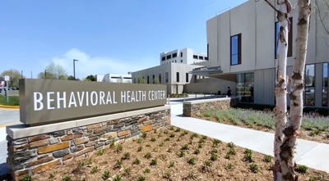
*Please note: The address is the same as the one for Duke Regional Hospital: 3643 N. Roxboro St. Durham, NC 27704. If coming from a different direction, once you enter Duke Regional Hospital, you should see “Behavioral Health Center” listed on the signs, with arrows towards the Center.
**For staff visiting conference rooms or staff attending training, please park in the Wisteria gravel lot behind visitor parking. The Behavioral Health Parking Lot is reserved for patients and their loved ones.

